PRODUCT PAGE

ESSENTIAL INFORMATION OF PRODUCTS AND SERVICES

Beauty product

Beauty product represent freedom of expression and individuality instead of being a sign of belonging to a certain group.

PRIMER

Price:Php 259.00

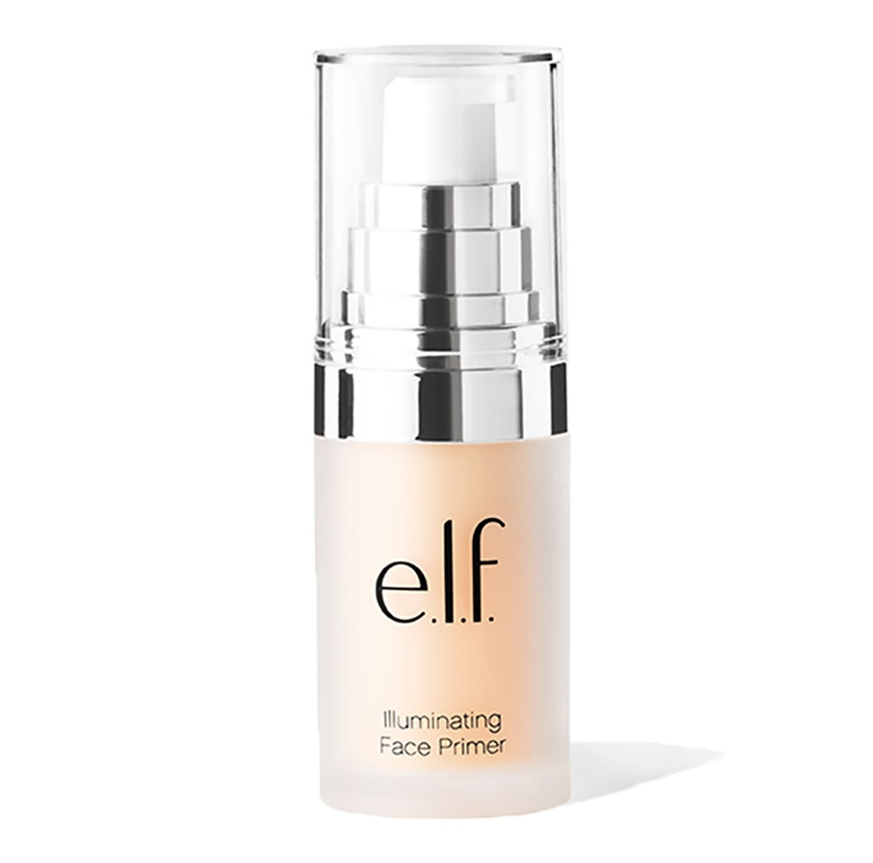  
**Primer makeup create a silky-smooth, poreless canvas for your makeup to adhere to, but it also helps your face and eye makeup stay on *all day*** without slipping, fading, or creasing.  It creates a smooth base for your foundation or bb cream to settle on and combats shine.

CONCEALER

Price:Php 295.00

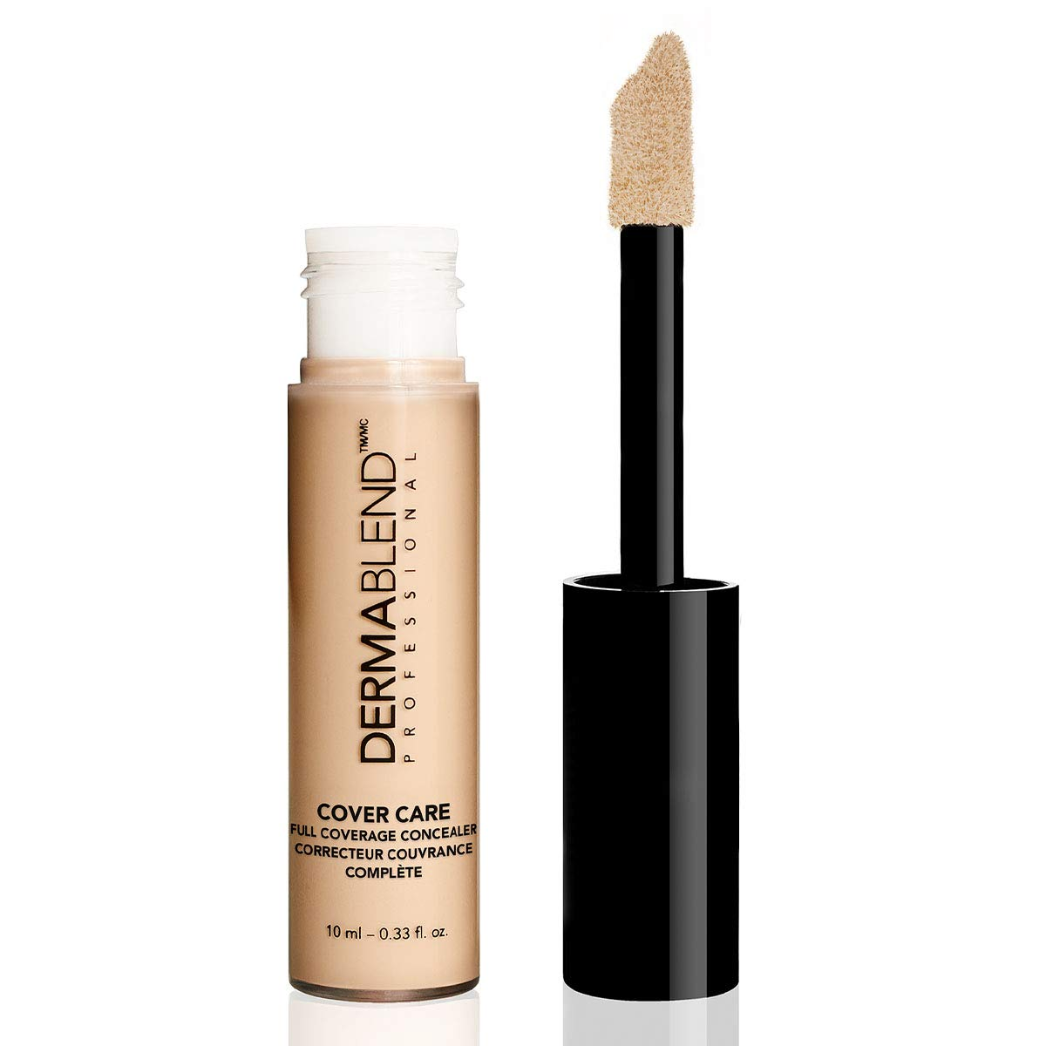

A concealer is a thick formula that is often one shade lighter than your foundation. It is usually applied after the primer and foundation if you have blemishes, freckles, discoloration, or dark circles.

BB Cream

Price:Php 159.00

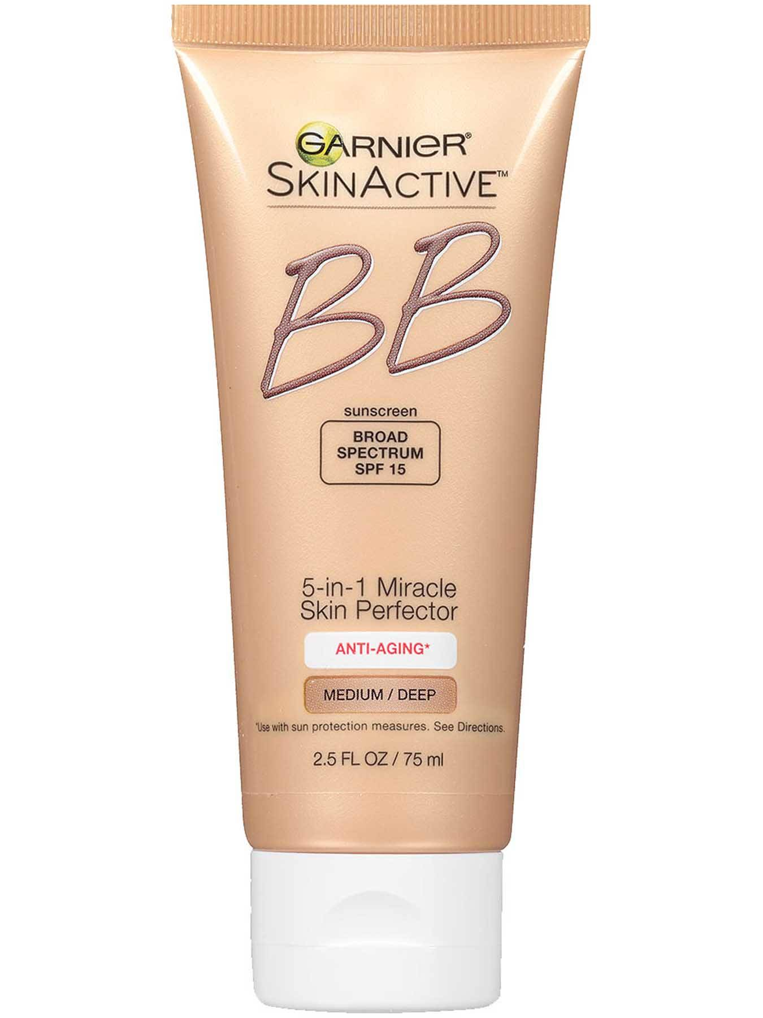

BB Cream is short for ‘blemish balm’ cream. It is a combination of products such as moisturizer, primer, sunscreen, foundation, and even concealer.

Foundation

Price:Php 269.00

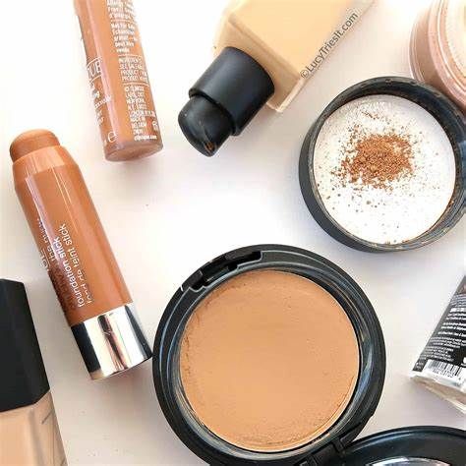

Foundation is the base of your make up. It goes on right after you apply the primer, and helps create a balanced, neutral skin tone.

LIPSTICK

Price:Php 349.00

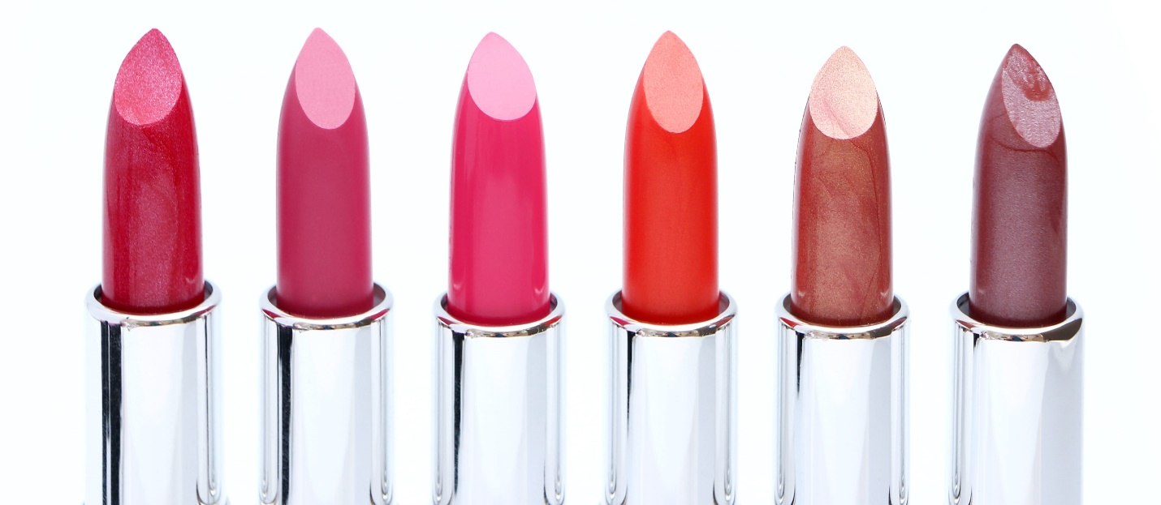

Lipstick available depending on what you prefer to use.

Mascara

Price:Php 239.00

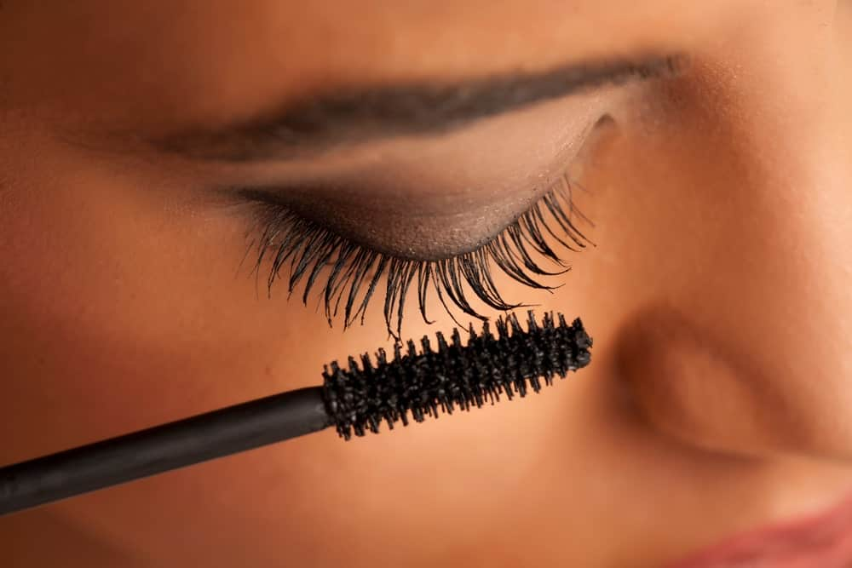

Mascara is a**cosmetic commonly used to enhance the upper and lower eyelashes**.